**Project Spyn - Demonstration**

**The Akatsuki group**

**Team Members Names:**

Rakshith Reddy Mudigolam

Mukesh Tulluru

Gayathri Kota

Naga Sathvik Kommareddy

Mrudula Eluri

**Pictures of the Final Design:**

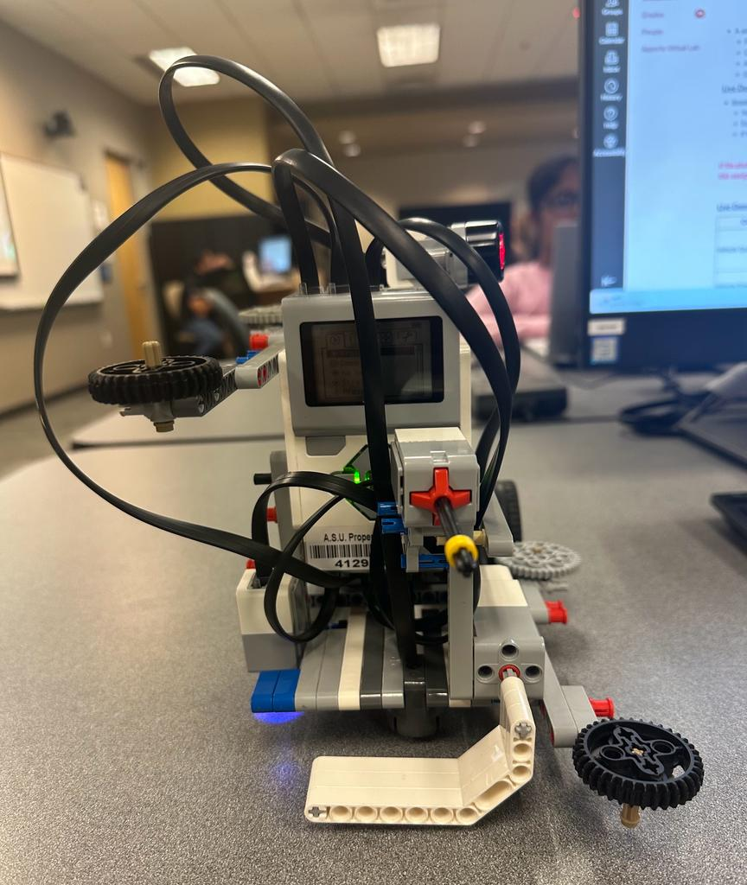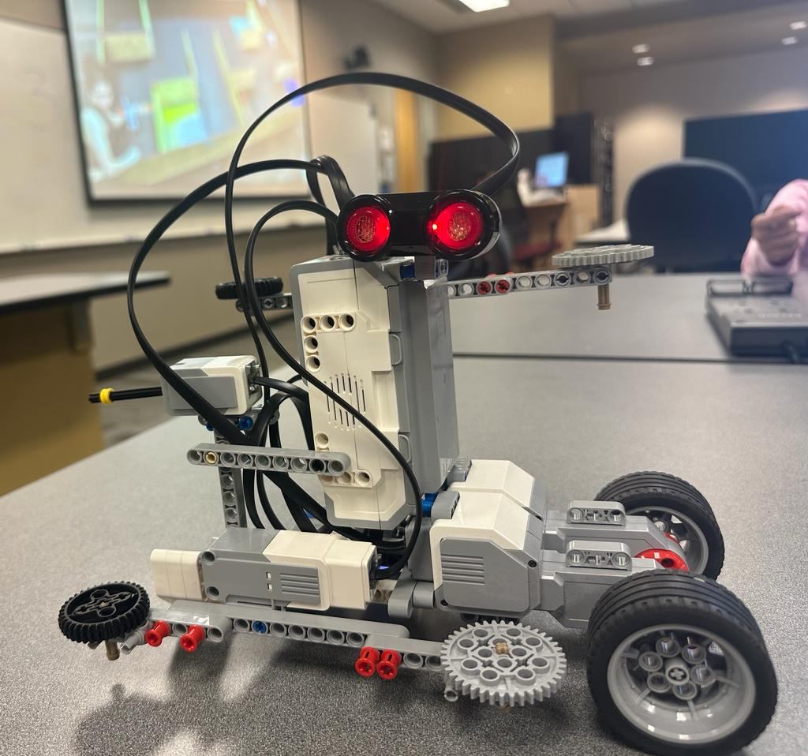

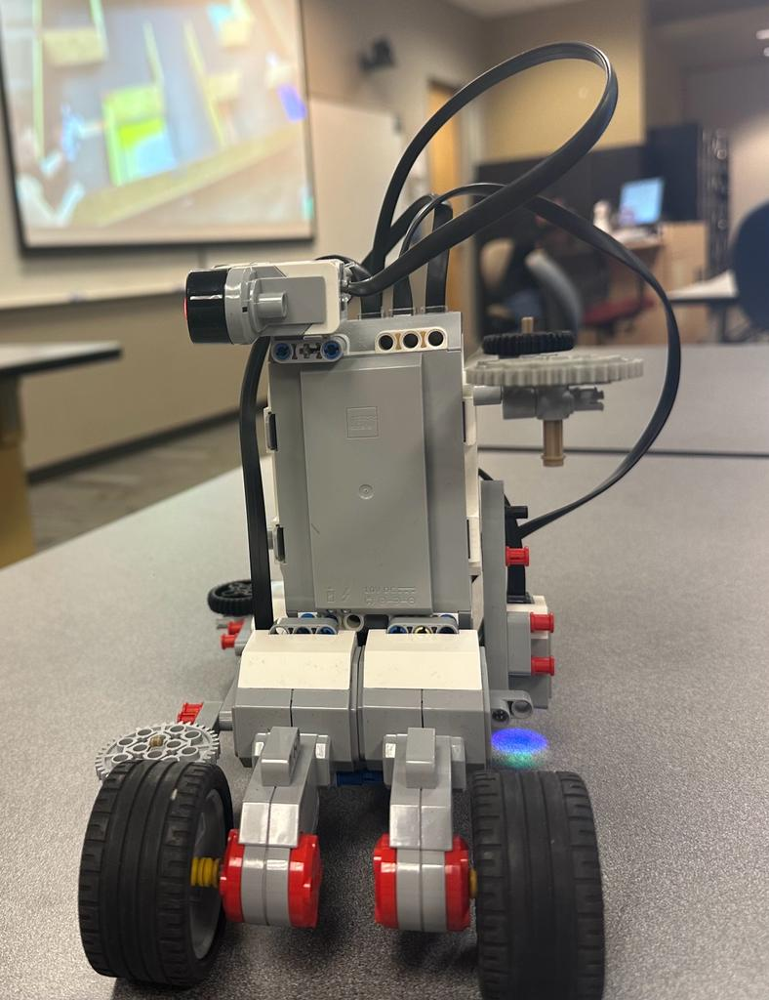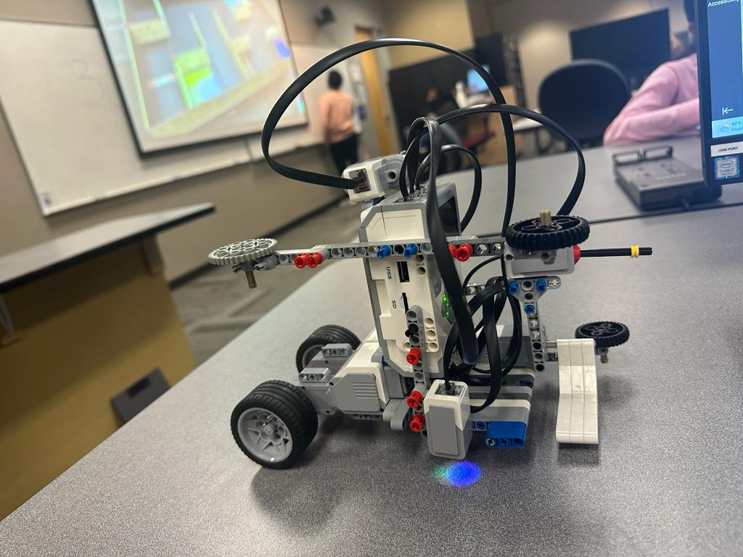

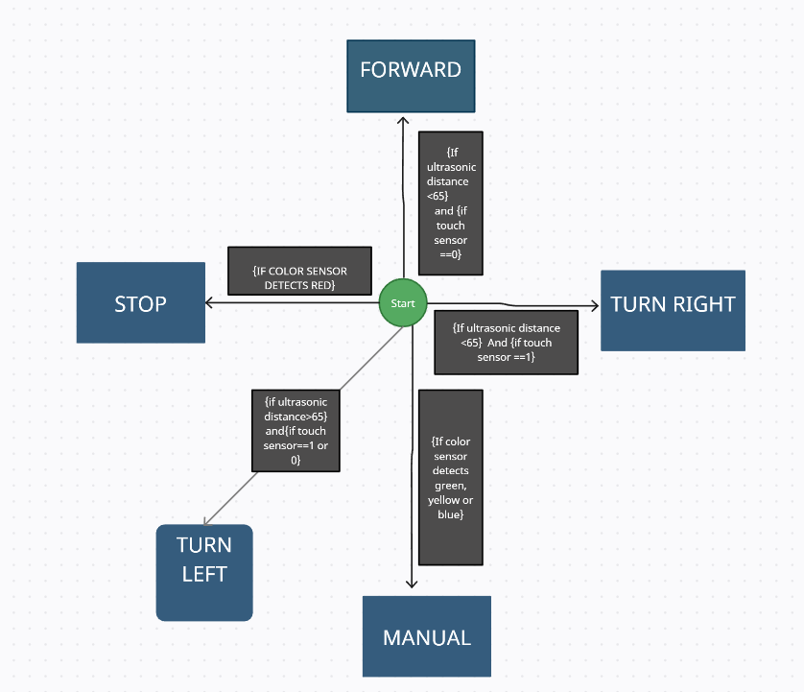

**Youtube link for the Car demonstration video:**

[**https://youtu.be/BWAP3AxwybM**](https://youtu.be/BWAP3AxwybM)

**Final Project Code Zip File:**

[**FSE Final ZIP Code.zip**](https://drive.google.com/file/d/1p-6sWoqx0wEIfQTGdDSqEyjsxUeofUyj/view?usp=sharing)